14.53: For the barge to be completely submerged, the mass of water displaced would need to be The mass of the barge itself is

so the barge can hold 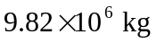of coal. This mass of coal occupies a solid volume of 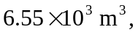which is less than the volume of the interior of the barge 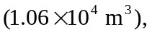
but the coal must not be too loosely packed.

